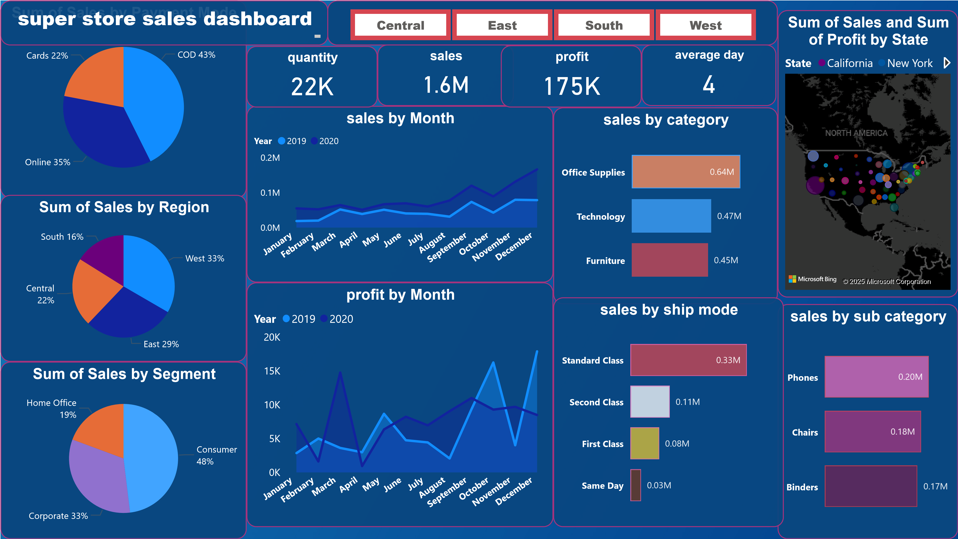

Power BI Desktop



sales forecast-15 days

**Jan 2019**

**Apr 2019**

**Jul 2019**

**Oct 2019**

**Jan 2020**

**Apr 2020**

**Jul 2020**

**Oct 2020**

**Jan 2021**

Sales forecast -15 days

**Nov 2020**

**Dec 2020**

**Jan 2021**

**K**

**2.98**

**10.59**

**K**

**K**

**0.41**

**K**

**8.14**

**K**

**9.68**

**K**

**0.21**

**super store_sales forecast 15 days forecast**

Sales by State

**California**

**New York**

**Texas**

**Washington**

**Pennsylvania**

**Ohio**

**Illinois**

**Florida**

**Michigan**

**North Carolina**

**M**

**0.34**

**M**

**0.19**

**M**

**0.12**

**M**

**0.09**

**0.08**

**M**

**0.07**

**M**

**0.06**

**M**

**0.05**

**M**

**M**

**0.05**

**0.04**

**M**

Power BI Desktop



